# TOPIC: WhiteLibrary interact with WPF default Controls

## Research Items

|  |  |  |  |
| --- | --- | --- | --- |
| **No** | **Item Details** | **Status** | **URL** |
| 1 | Create a sample WPF application contains all default controls | Done | <https://github.com/mtran21081990/WinAppAutomation/tree/master/SampleApplication/WPF_Application> |
| 2 | Create a test suite to run automation on sample WPF application | Done | <https://github.com/mtran21081990/WinAppAutomation/blob/master/SampleProjects/WhiteLibraryAutomation/Tests/Suites/sample_test_not_use_settings.robot> |
| 3 | Run test suite and report result | Done |  |

## Research Details

*1. Sample WPF application*

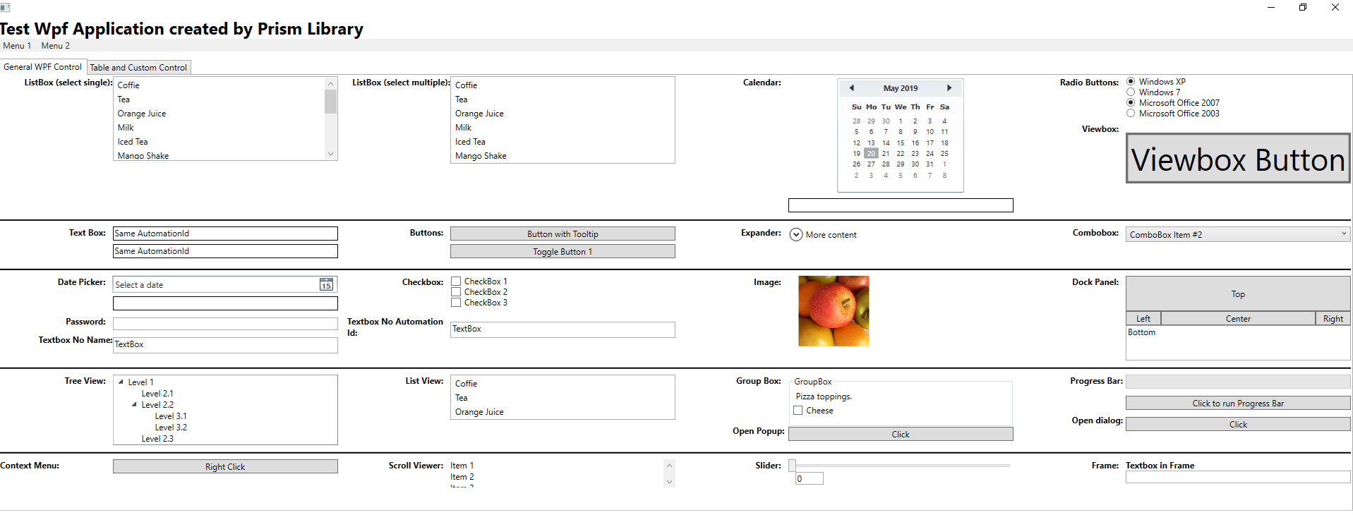

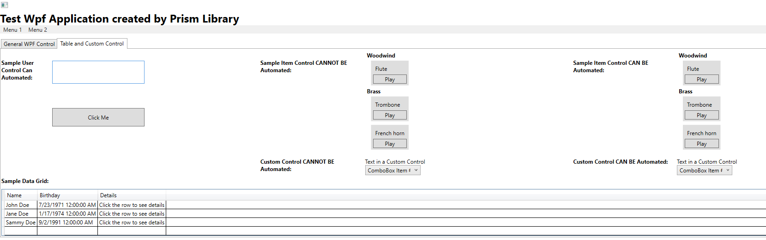

Below is list of controls:

|  |  |  |  |  |  |
| --- | --- | --- | --- | --- | --- |
| ListBox | Calendar | RadioButton | Viewbox | TextBox | Button |
| ToggleButton | Expander | Combobox | DatePicker | PasswordBox | CheckBox |
| Image | DocPanel | TreeView | ListView | GroupBox | Popup |
| Dialog | ContextMenu | Slider | Frame | UserControl | CustomControl |
| DataGrid | TabControl |  |  |  |  |

All controls are specified with unique AutomationId and Name attributes (except some controls with same AutomationId or empty to test many situations).

*2. Sample Test Suite*

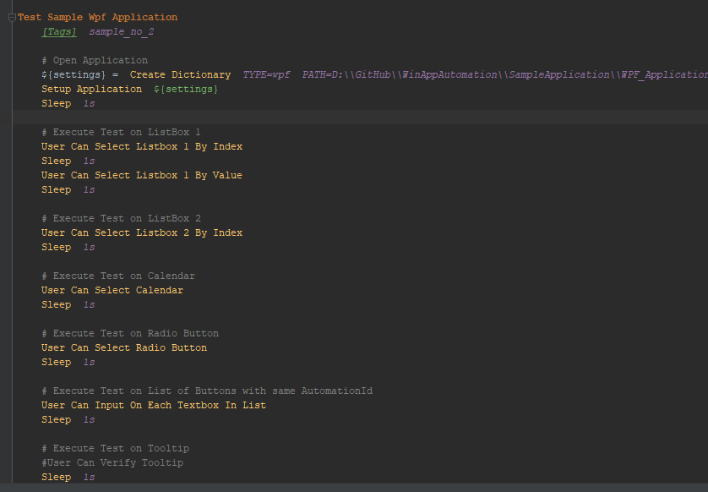

*3. Test Results*

|  |  |  |  |
| --- | --- | --- | --- |
| **Control** | **Keywords to use** | **Status** | **Notes** |
| ListBox | *Select Listbox Index*  *Select Listbox Value*  *Listbox Selection Should Be* | In Progress | *Listbox Selection Should Be* will be incorrect if Listbox allow multi-selection. Need to revise this keyword. |
| ToggleButton | *Click Button* | In Progress | Can click but cannot get Toggle State. Need to revise this keyword. |
| Calendar | *Click Button* | In Progress | Need to develop keyword for this control: input: date, output: select correct date on calendar. |
| Radio Button | *Select Radio Button*  *Get Radio Button State* | Done |  |
| TextBox | *Input Text To Textbox*  *Verify Text In Textbox* | Done |  |
| ToolTip | *Window Tooltip Should Equal To* | In Progress | Not Working |
| Expander | *Click Button* | In Progress | Need to create keyword to click on its 1st button |
| Combobox | *Select Combobox Value*  *Verify Combobox Selection* | Done |  |
| DatePicker | *Click Button* | In Progress | Need to develop keyword for this control: input: date, output: select correct date on DatePicker. |
| PasswordBox | *Input Text To Textbox* | Done |  |
| Checkbox | *Toggle Check Box*  *Verify Check Box* | Done |  |
| TreeView | *Double Click Tree Node*  *Select Tree Node* | Done |  |
| Dialog | *Attach Window* | In Progress | Need to develop keyword to wait for dialog to displays |
| ContextMenu | *Right Click Item*  *Click Item In Popup Menu* | Done |  |
| Slider | *Set Slider Value*  *Verify Slider Value* | Done |  |
| TabControl | *Select Tab Page* | Done |  |
| DataGrid | None | In Progress | Need to develop keyword for this control |